<https://www.youtube.com/watch?v=okjYjClSjOg&list=PLblh5JKOoLUK0FLuzwntyYI10UQFUhsY9&index=33>

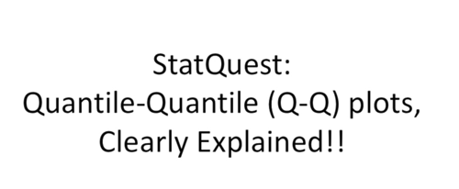

Today we're gonna be talking about quantile, quantile plots.

These are called QQ plots sometimes and they're gonna be clearly explained.

This stat quest assumes you already know what a quantile is if you don't.

Nno big deal !

Just check out the stat quest on quantiles and percentiles and then you can watch this one in or make a lot more sense.

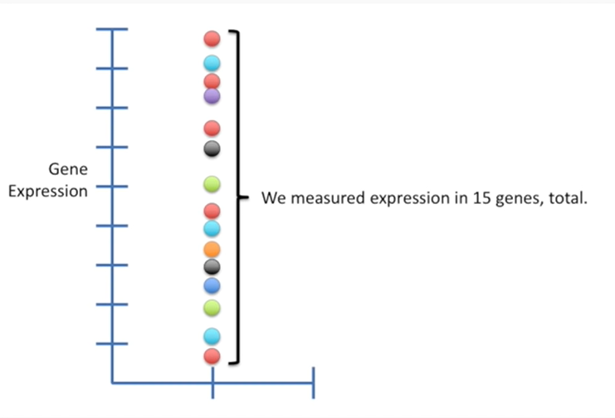

We'll start with this data set where we measured expression in 15 genes, total.

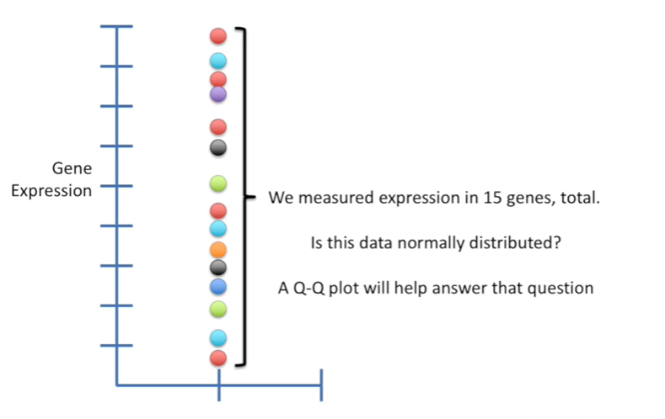

One question we might have is is this data normally distributed ?

A QQ plot will help answer that question.

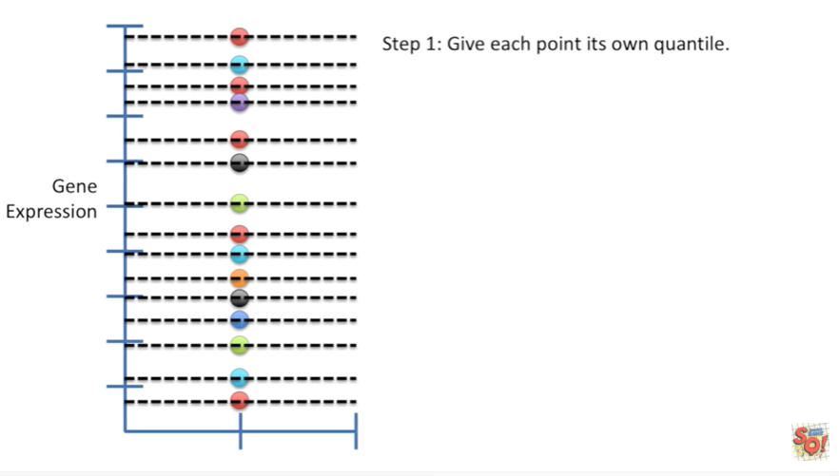

Step 1 give each point its own quantile.

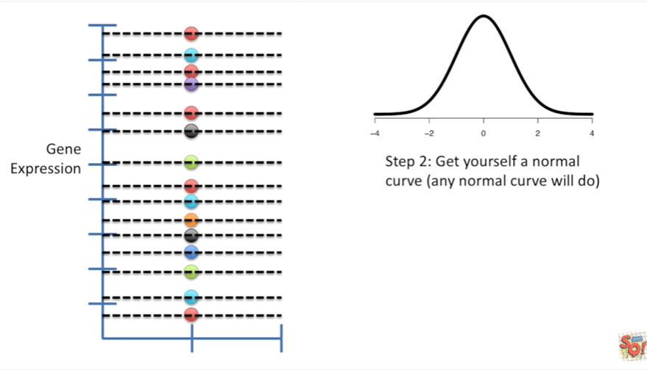

Step 2 get yourself a normal curve any normal curve will do.

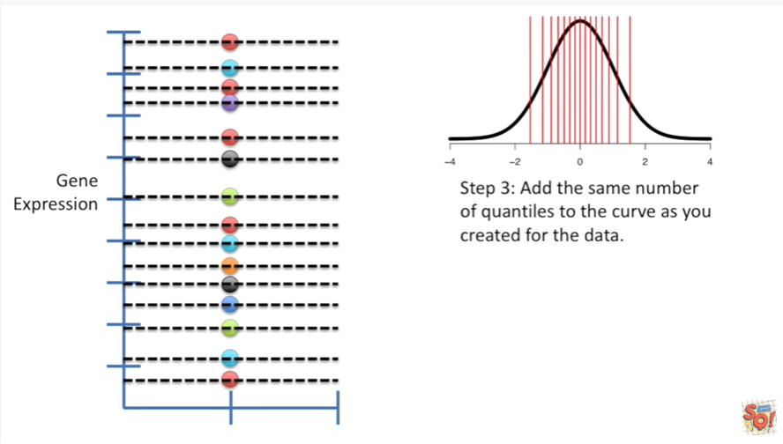

Step 3 add the same number of quantiles to the curve as you created for the data .

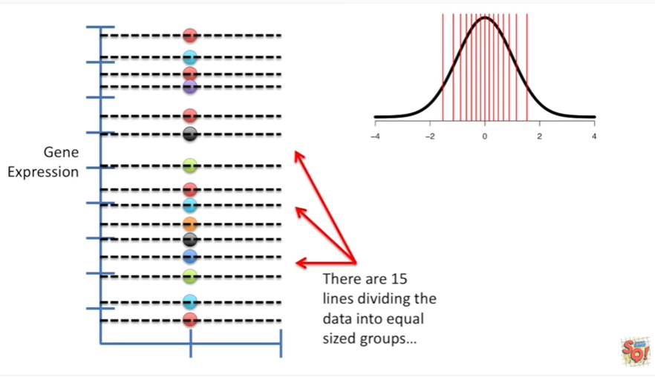

That is to say there are 15 lines dividing the data into equal sized groups

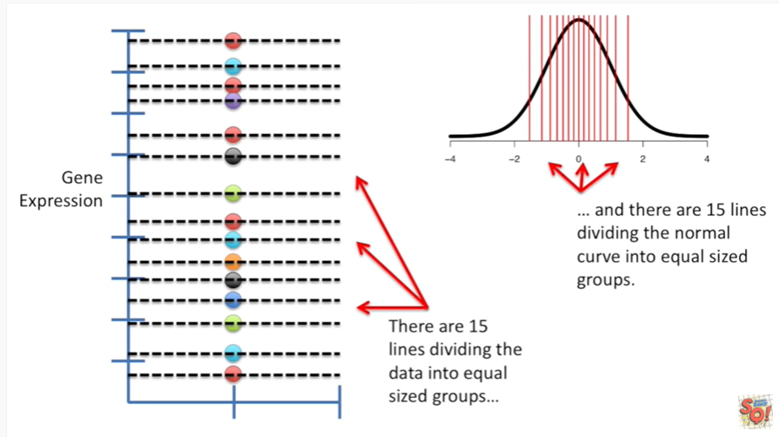

and there are 15 lines dividing the normal curve into equal sized groups.

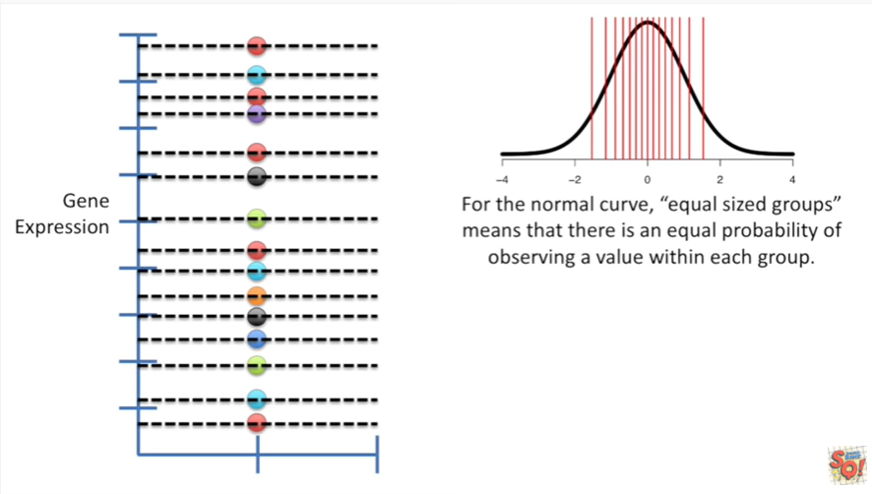

For the normal curve equal sized groups means that there is an equal probability of observing a value within each group.

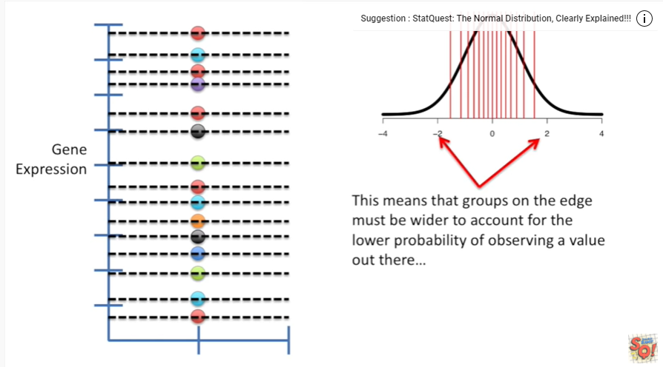

This means that groups on the edge must be wider to account for the lower probability of observing a value out there

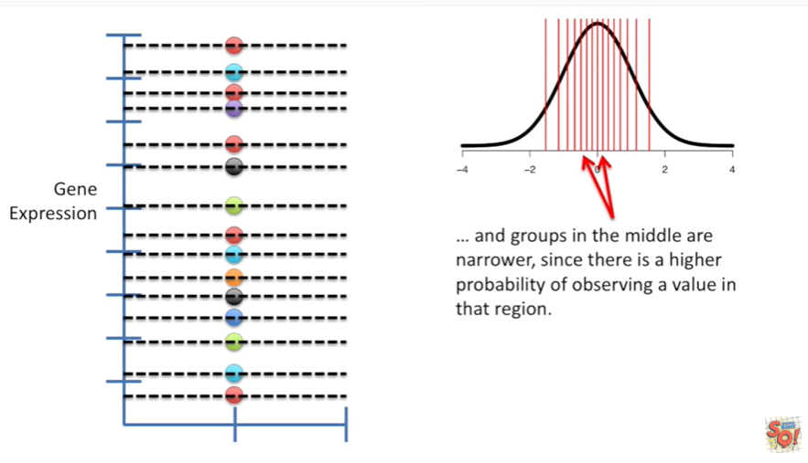

and groups in the middle are narrower since there is a higher probability of observing a value in that region.

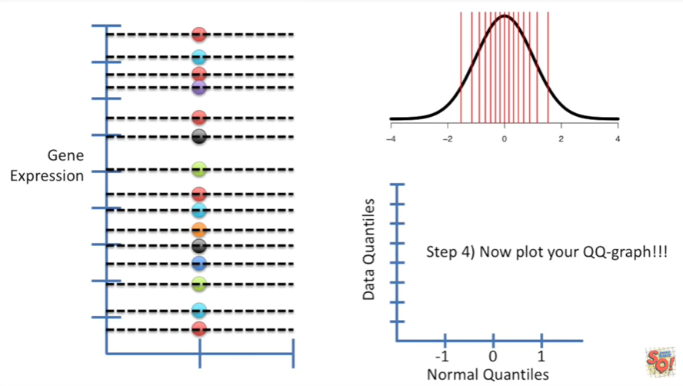

Step 4 now plot your QQ graph !!!

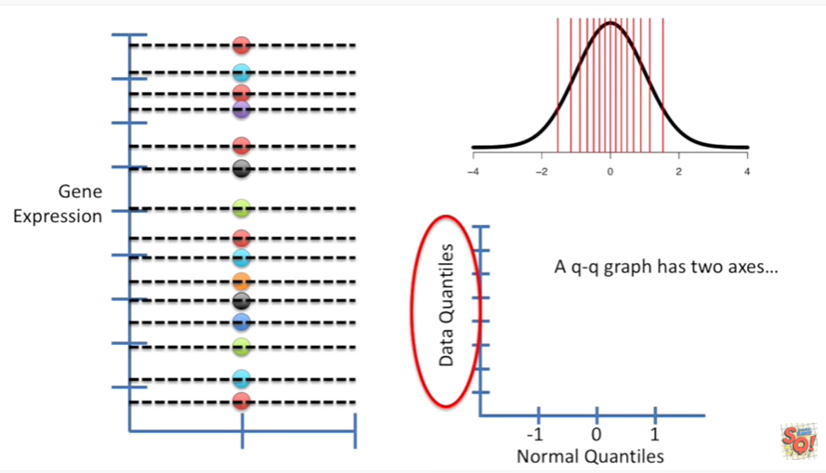

A QQ graph has two axes

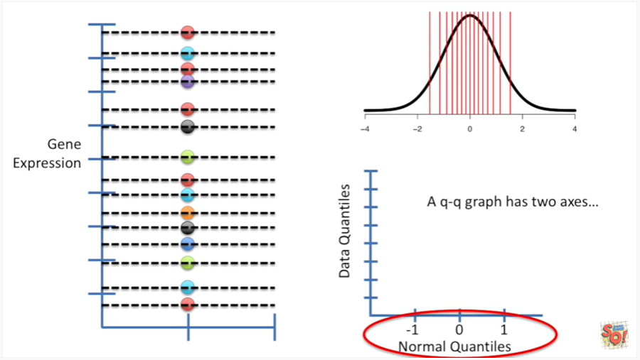

one for the quantiles that we generated from our data set and one for the quantiles we generated from the normal distribution.

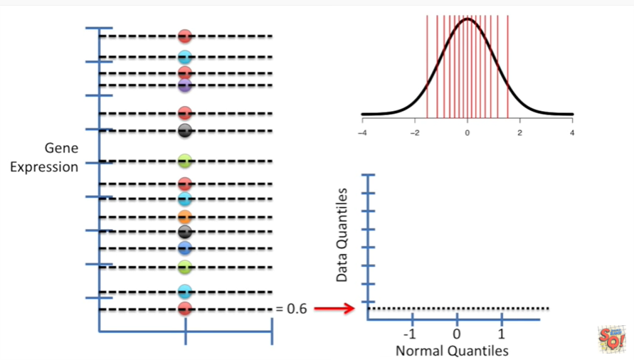

We'll start with the smallest quantile in our data set this quantile is at 0.6 and our data set.

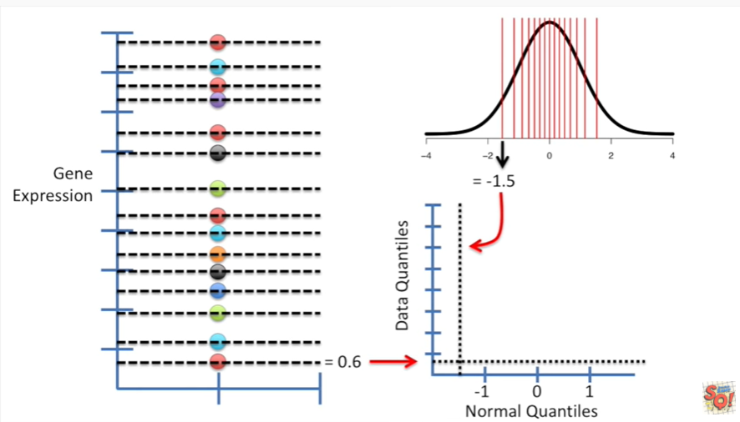

And so we'll draw a dotted line on the QQ plot to indicate that location then we draw a vertical line representing the position of the smallest quantile in the normal distribution.

This quantile is at negative 1.5.

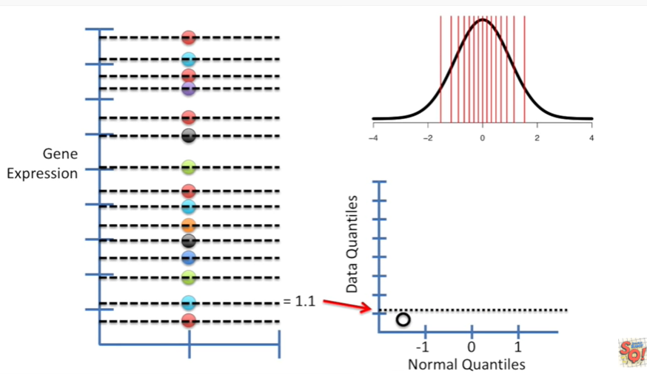

So that's where our vertical dotted line goes now all we do is put a dot where those two lines intersect.

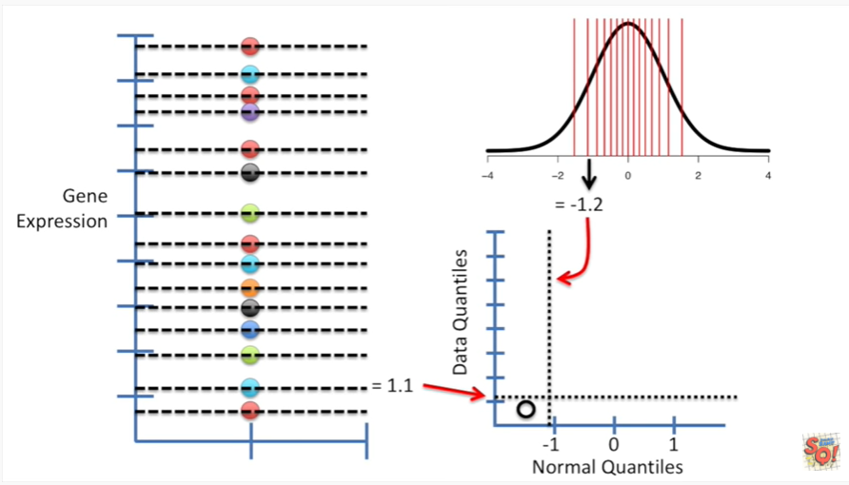

Now we move on to the second quantile in the data set that we collected.

This one is at one point one.

So we have a horizontal dotted line at one point one in our quantile quantile graph.

Then we draw a vertical line at the location of the second quantile in the normal distribution.

This quantile is at negative 1.2.

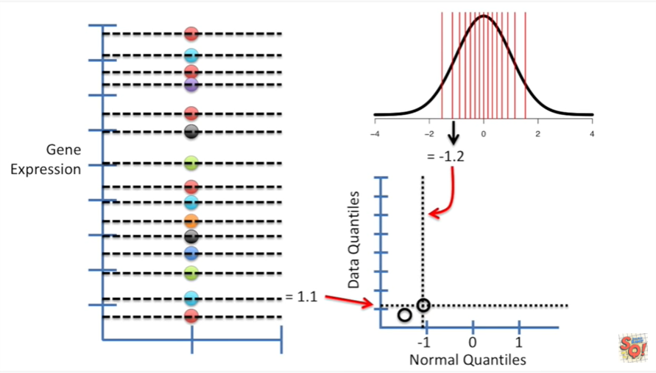

So we draw a vertical line at negative 1.2 then we draw a dot where the two lines intersect

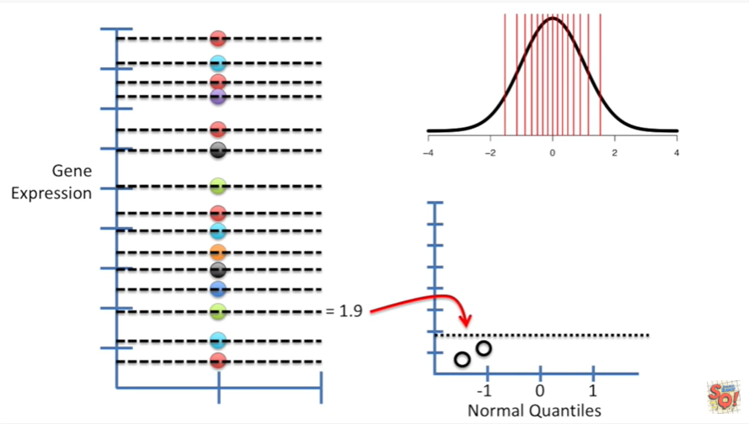

The third quantile in the data set that we collected is at 1.9.

So we draw a horizontal line at 1.9.

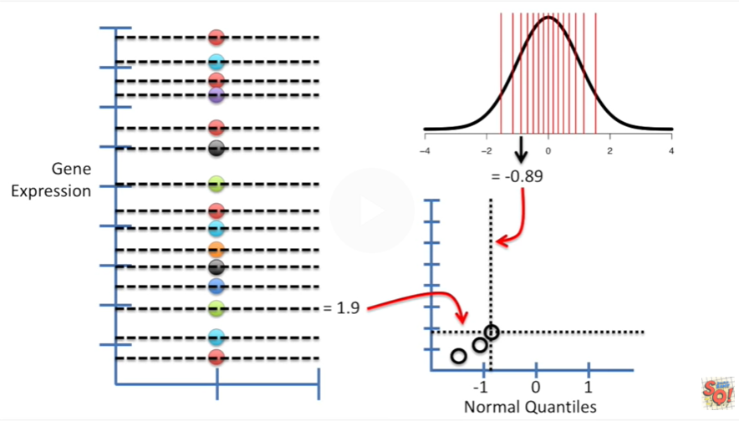

And the 3rd quantile in our normal distribution is at negative zero point 8 9.

So we draw a vertical line at that position and then we draw a dot where the two lines intersect.

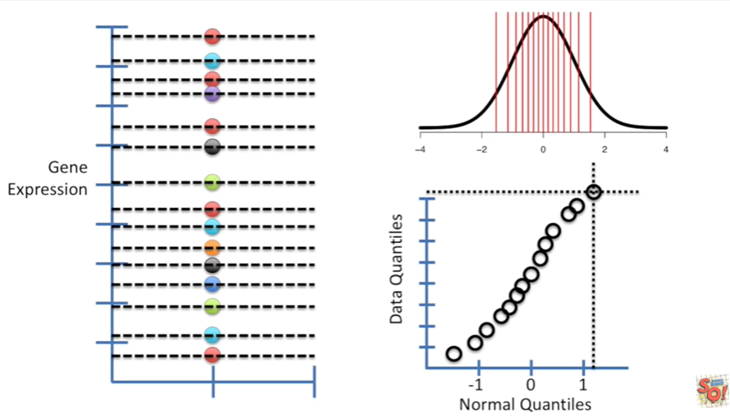

And then we just do the same thing over and over.

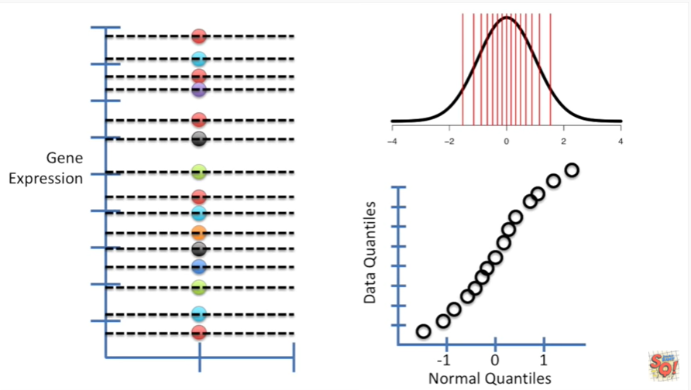

Again for each quantile until we have all the quantiles represented in our quantile quantile graph.

Hooray !!!

Now we've got dots showing where the quantiles from our data set intersected with the quantiles from the normal distribution on our graph.

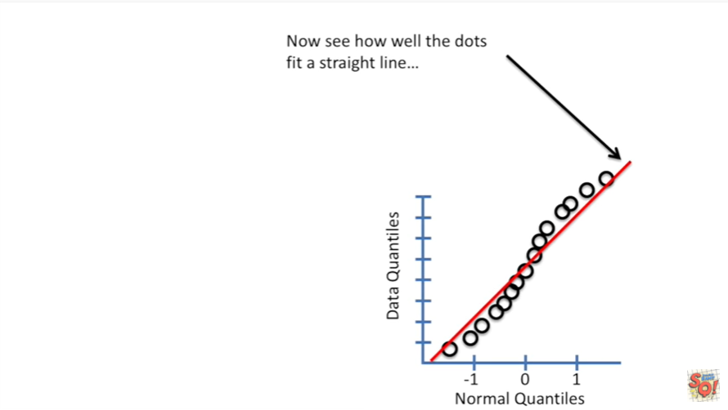

Now we see how well the dots fit a straight line

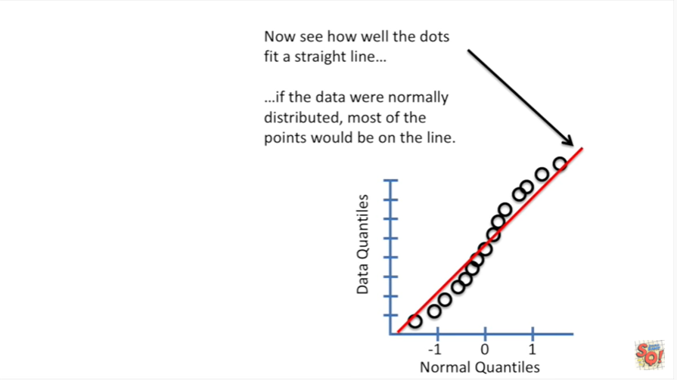

if the data were normally distributed most of the points would be on the line.

This would mean that both the data set and the normal distribution have comparable quantiles.

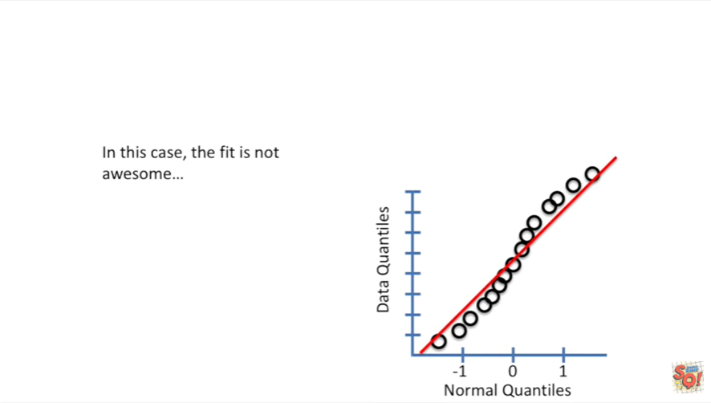

In this case the fit is not awesome

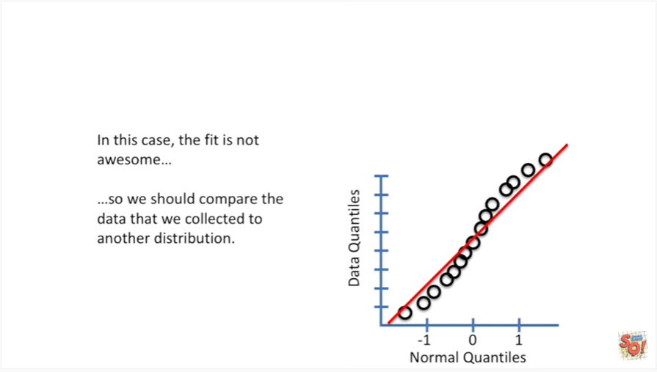

so we should compare the data that we collected to another distribution.

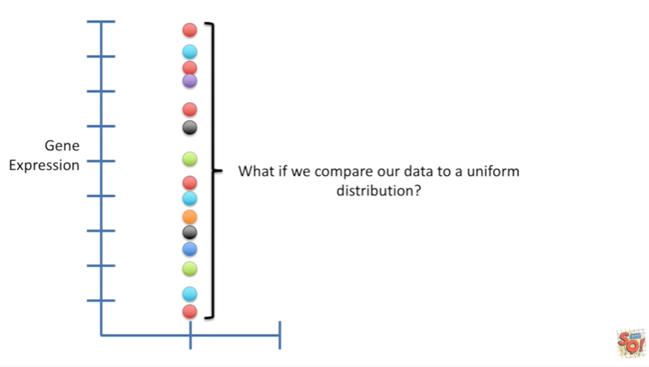

What if we compare our data to a uniform distribution ?

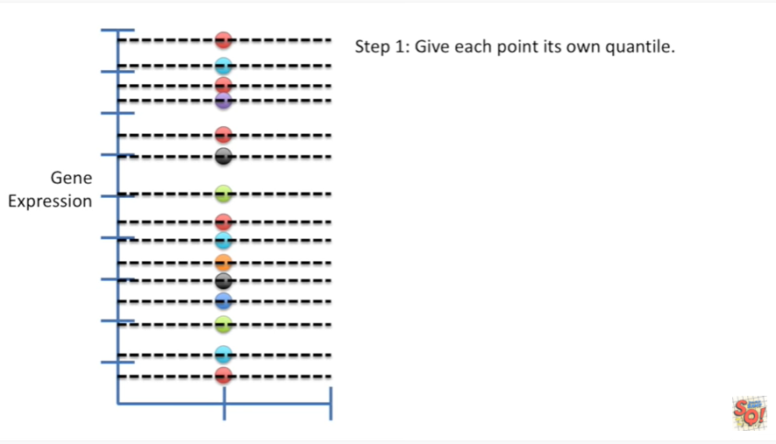

The process is the same :

Step 1 give each point its own quantile.

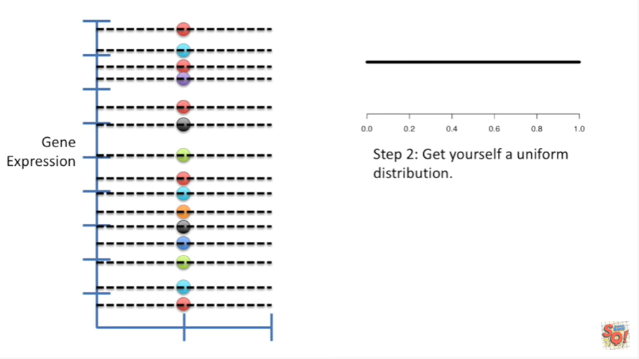

Step 2 get yourself a uniform distribution.

Any old uniform distribution will do.

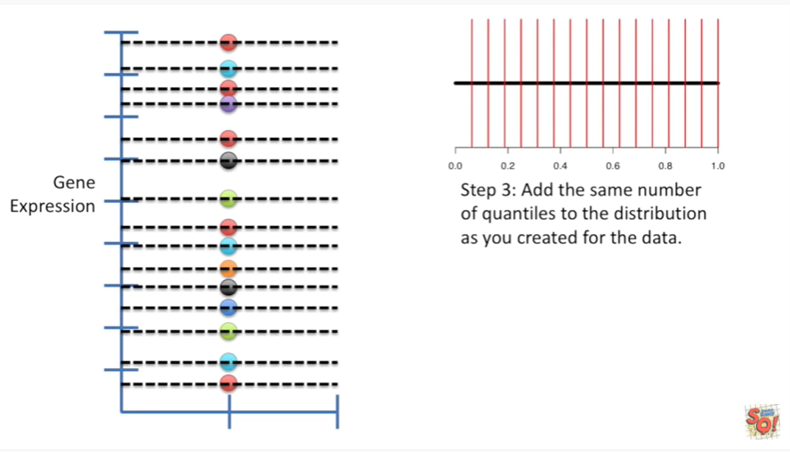

Step 3 add the same number of quantiles to the distribution as you created for your data.

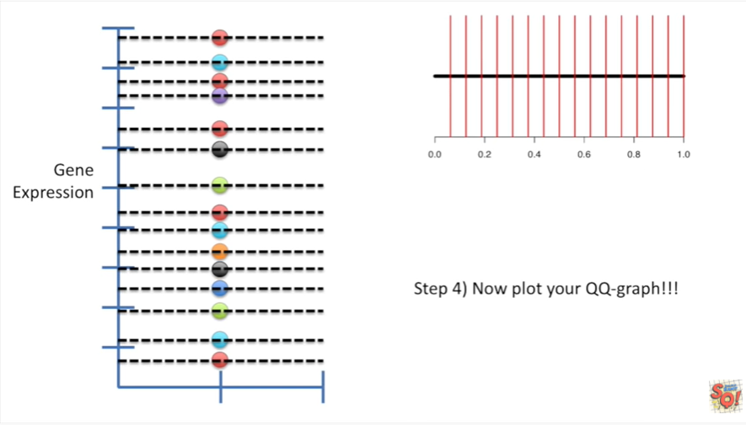

Step 4 now plot your QQ graph !!!

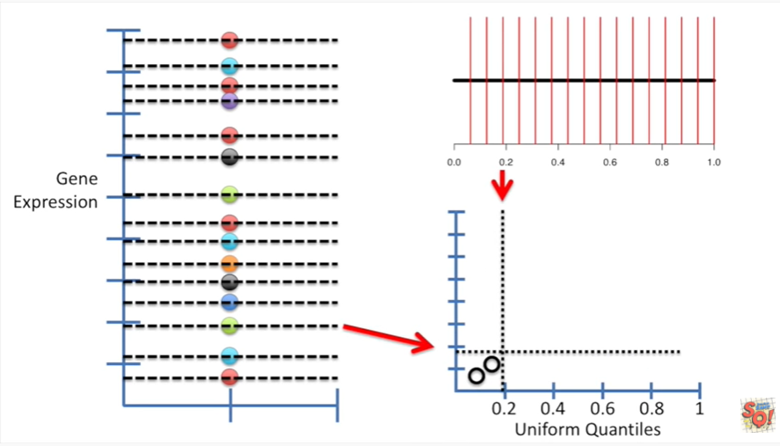

Just like before we've got the data quantiles on the y axis and the distribution quantiles on the x axis.

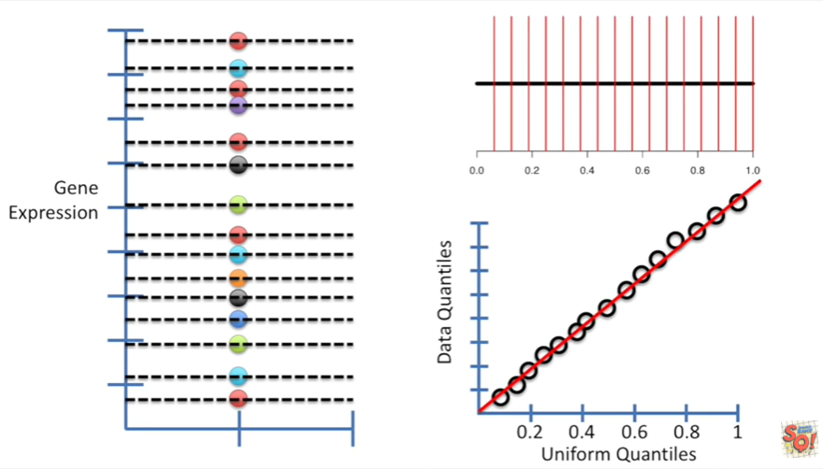

Now we draw a straight line that goes through the points in the graph and look.

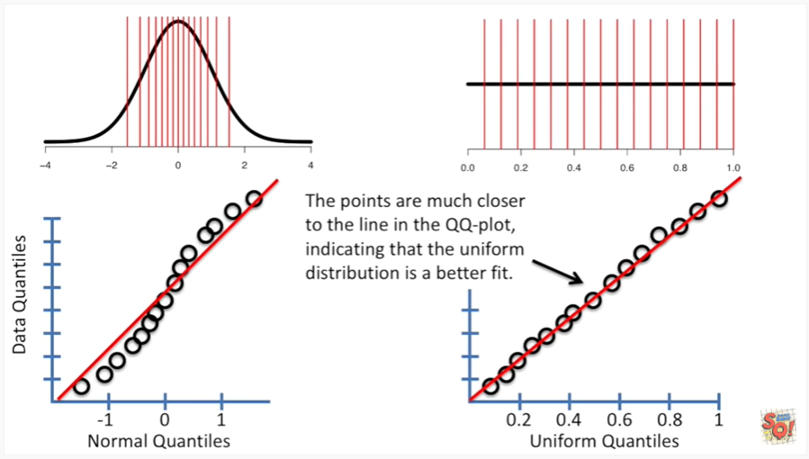

The points are much closer to the line in the QQ plot indicating that the uniform distribution is a better fit.

So if you're ever wondering which distribution matches your data well you could use QQ plots to answer that question ok.

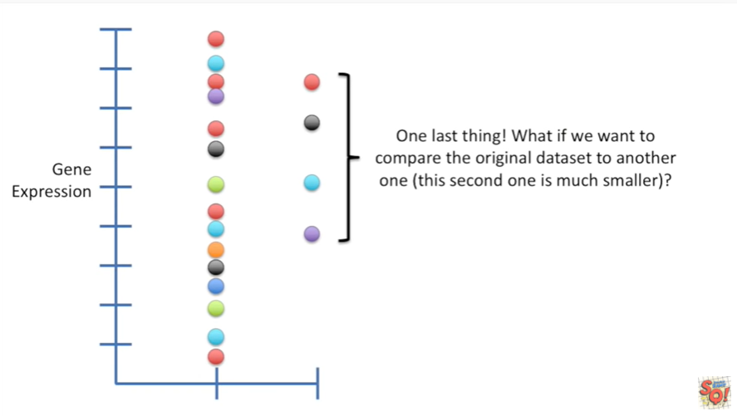

One last thing before we're done !

What if we want to compare the original data set to another one this second one is much smaller.

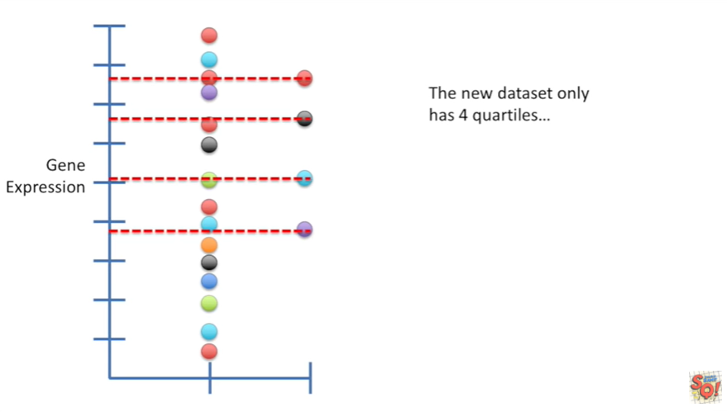

The new data set only has four quartiles quartiles are just quantiles when you only have four of them.

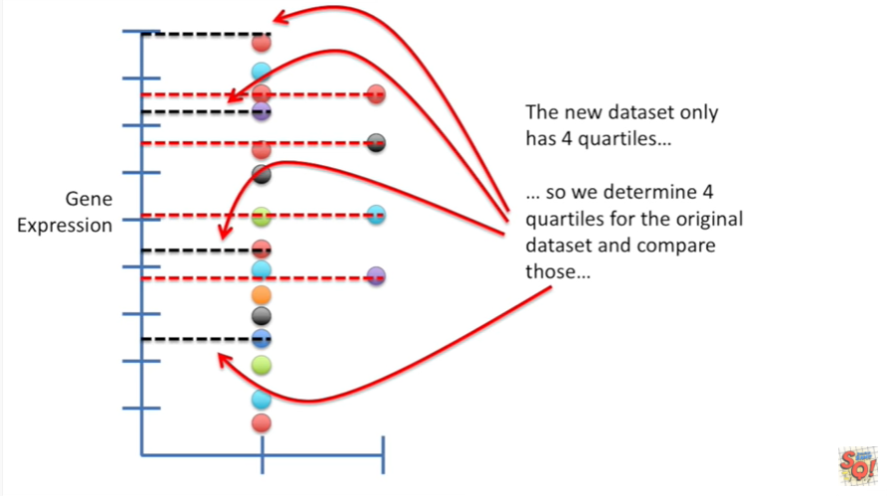

So we determine four quartiles for the original data set and compare those .

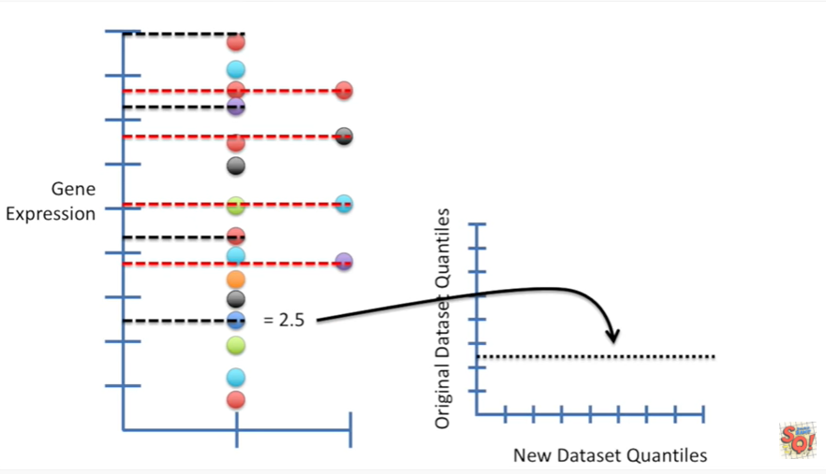

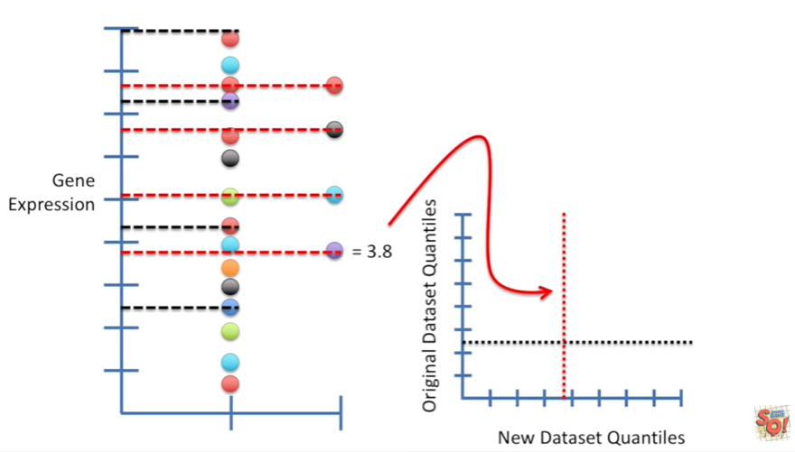

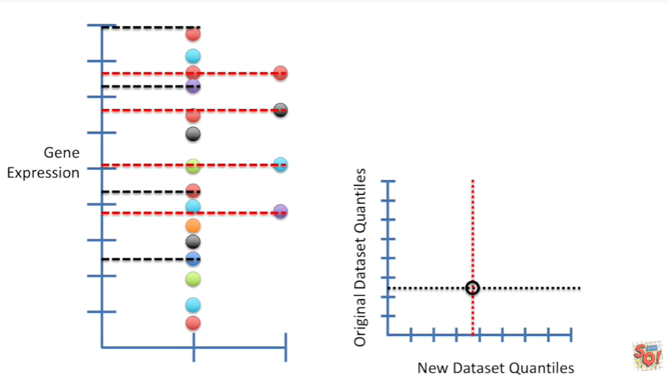

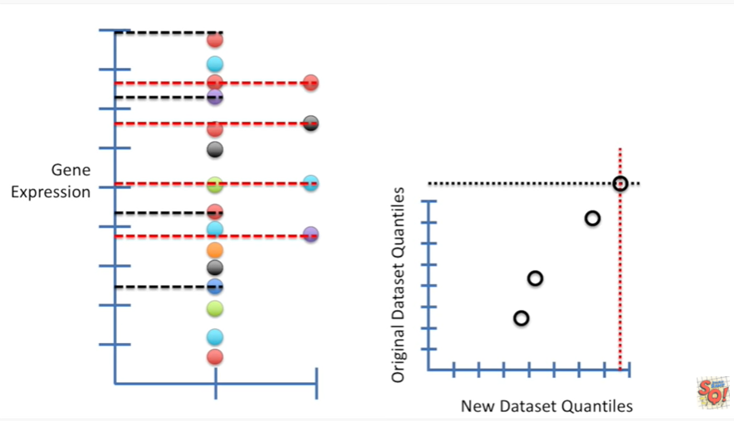

And just like we did when we compared the data set that we gathered to the normal distribution and the uniform distribution we plot a QQ plot by drawing horizontal and vertical lines representing the quantiles from the two data sets that we collected.

And where the two lines intersect we draw a dot and we just repeat this process for each pair of quantiles until we have all the quantiles represented on the graph.

Hooray !!

Now we've got all the quantiles plotted on our QQ graph.

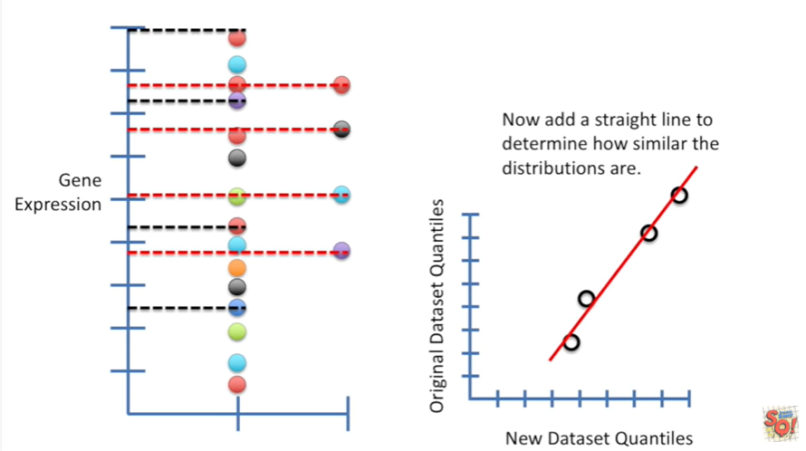

Now at a straight line to determine how similar the distributions are.

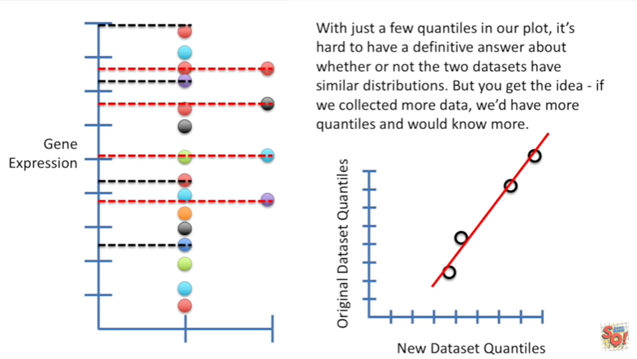

With just a few quantiles in our plot it's hard to have a definitive answer about whether or not the two data sets have similar distributions.

But you get the idea if we collected more data we'd have more quantiles and would know more.